ECE 2564

Project 1: Pixel Monarch
Fall 2025

How do I read this document?
Our goal has been to provide you with as much information and tools as possible to help you succeed with the project. Nevertheless, you might not need to read the entire document at first. We recommend that you take a quick look at it to know the main topics covered. Then, carefully read the Game Description and Code Quality sections, and begin your design. Once you have made some progress with your project, carefully study the Validation section. Whenever you have any questions, you should first try to find your answer in this document. The Design Strategy section contains tips and advice on completing certain parts of the project.

Fundamentals

!!! General Guidelines for any assignment
- Before you start working on your assignment:

  - Skim through the entire project description and carefully read the essential sections marked with exclamation marks (!!!).

  - Read the starter code carefully and in its entirety.

  - Run the provided F25_Proj1_golden.out on your board. This is an executable that we call the golden solution.

- Every time you sit down to work on your assignment:

  - Before you start coding, go to Piazza, and read the questions/notes related to the assignment you are working on, even if you took a two-hour break.

  - After you finish coding, push your changes to GitHub, even if you are going to take a two-hour break!

Starter Code
To get the starter code, follow the instructions for accepting assignments and importing projects from the CCS/GitHub Integration course website page. Please make sure to use GitHub Desktop or CLI. Instead of using the assignment link in the tutorial, you will need to use the below link:

https://classroom.github.com/a/T-9S-B0F

!!! Honor Code Policy
You are allowed to copy code from any previous program given to you as part of the course material (HW, class examples, course website, etc…). However, copying/inheriting code from outside/external resources constitutes plagiarism. If you have any questions whether your research or design falls under “fair use”, do not hesitate to contact the Professor, a GTA, or a UTA.

!!! Generative AI Policy
You are not allowed to use the code generated from Generative AI models such as ChatGPT, Gemini, Copilot… etc. However, you can use these tools to assist in debugging or enhancing the readability of your code.
Similarly, when writing your report, you may use Generative AI to improve and edit what you write, but you cannot use someone else’s writing as the input to the chatbot or ask the chatbot to write the report for you. If you use Gen-AI either to polish your report or to polish your code, you need to download the entire conversation with Gen-AI as a pdf and attach it to your report as an appendix.

!!! Late Policy
Please refer to the syllabus for the late policy, which is very similar to the homework late policy in the past. The only small difference is that for projects, the report is due 24 hours after the code. If you “buy” yourself a day or two of extension for the project, your code and report are both extended for 24 or 48 hours.

Golden Solution
We are providing a golden solution executable. The purpose of this file is for you to observe the behavior of the project in action. The executable is called F25_Proj1_golden.out and is provided in the github. Follow the instructions here to flash the microcontroller with the executable file. If there is any difference between the golden solution and the project description, please follow the project description. Please also bring that issue up on Piazza so that we are aware of it. (A “bonus” golden solution containing some features that are considered a bonus may be provided for you. These bonus features are not required and are simply just examples. Please read this document carefully so you know what features are actually required.)

!!! Submission Process
The submission process has two steps:
- Submitting your code:
- Putting your code on the cloud:
You will have to submit your project to GitHub by the deadline. It is extremely important that you make sure that you have uploaded all your files, including custom images, if any, to GitHub.
For any reason, if you are unable to submit your work to GitHub, zip up your work, and fill out the Help Ticket form which has a place for you to upload it.
- Submitting a screenshot of your GitHub submission on Canvas.
2) Submitting your report, which is due 24 hours after the code deadline.
You will have to submit your report to Canvas as a PDF.

Button/LED Names
In this project, we will use the LEDs and buttons on both boards. We will use the same naming convention as our previous assignments, as shown below. For the BoosterPack LEDs, we will refer to the collection of all three LEDs as BLED, which can be turned into a variety of colors.

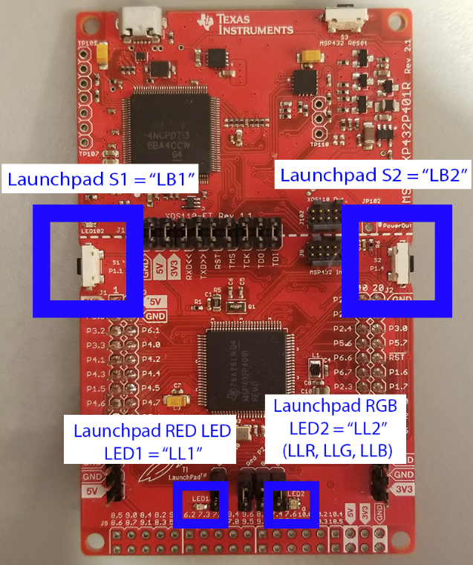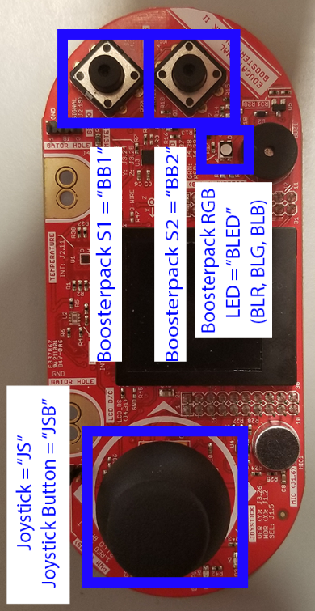

Game Description

Introduction
In this project, you will create a game where you rule a kingdom and have to make sure it survives various blights and attacks from raiding kingdoms. The player makes decisions using various inputs via UART. The objective is to survive as long as possible while ensuring none of your resources reach 0 and you don’t lose control of all your land.

The game will be primarily controlled through the UART and GPIO buttons, while the LCD on the BoosterPack is used to display game information. You will also practice implementing finite-state machines (FSMs) by designing different “screens” or “scenes” for your game (e.g. main menu screen). This project will also test your ability to utilize arrays/strings in C.

Main Menu Screen
When the player starts the game, they should be greeted with a title screen displaying the game's name, the developer’s name (your name), and basic instructions on how to navigate the menu.

The title screen will have a menu with the following options: Play Game, Instructions, and High Scores, with a cursor indicating the currently selected option.

- Pressing BB1 selects the option the cursor is on.
- Pressing BB2 cycles the cursor.
  - The cursor should circularly increment, i.e. when you are on the bottom option, it should cycle back to the top.
  - Whenever you go back to the main menu, the cursor should start on Play Game

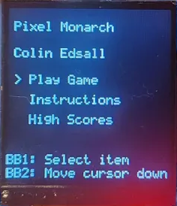

Instructions Screen
This screen should transition from the Main Menu screen. This screen should provide some instructions on how the game works in your own words and present the various states the game will encounter.
Tapping BB2 should go back to the title screen.
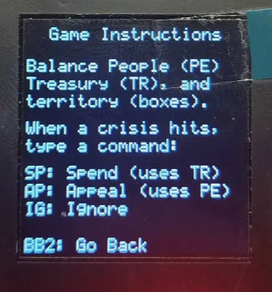

High Scores Screen
This screen should transition from the Main Menu screen. It should display the top five scores in descending order.
Pressing BB2 returns to the Main Menu screen.
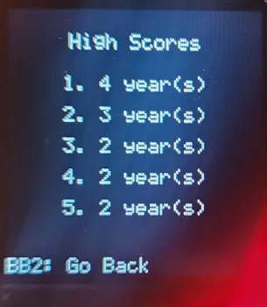

Game Screen
Most of the interactions on this screen should be over UART.

This screen should transition from the Main Menu screen. When selected, the player is presented with the game environment.

- People (PE)
- Treasury (TR)
- Year
- Territory
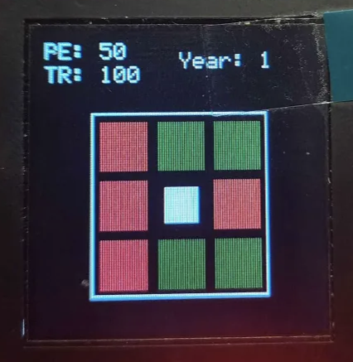

People
Treasury
Year

Territory

- People (PE) and Treasury (TR) are your currencies for this game; if either of them reaches 0, the game is over. Your year is the score for the game; it increments by 1 after every raid. Your territory is randomly generated at the start of the game, and what lands are green and red should be different after every game.
- The game starts with 100 TR and 50 PE.
- Raiders randomly attack a territory that is under your control.
- At the start of each year, you will be prompted with a random event. Based on each event, you can either Spend (SP), Appeal (AP), or Ignore (IG). These are the following four events
  - Flood ‘F’
    - IG: -5 TR, -5 PE
    - SP: -10 TR
    - AP: -10 PE
  - Famine ‘M’
    - IG: -10 TR, -5 PE
    - SP: -15 TR
    - AP: -15 PE
  - Raid ‘R’
    - IG: Region lost (no TR/PE loss)
    - SP: -20 TR, no region lost
    - AP: -15 PE, no region lost
      - A year passes when a raid event ends
  - Calm Period ‘C’
    - IG: +40 TR, +20 PE
    - SP[1-8]: -30 TR, chosen region is GREEN
    - AP[1-8]: -30 PE, chosen region is GREEN

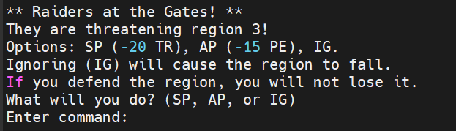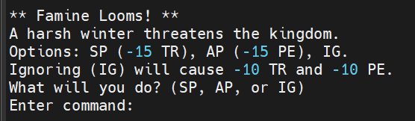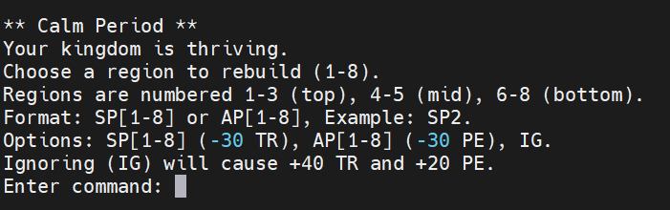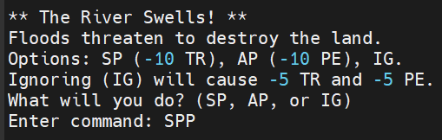

Game Over Screen
Upon either TR going to 0, PE going to 0, or losing control of all land, there should be a game over screen that either says “Your Kingdom Has Fallen!”, as well as displaying how many years you survived. On this screen, there should be an option to return to the main menu, where the user can either play again or go to the instructions screen or high score screen.
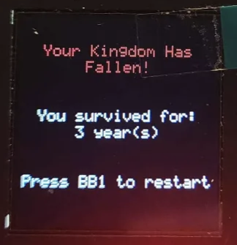

UART Requirements
The UART connection should be configured with the following settings: 8 data bits, one stop bit, LSB first, and no parity bit. Additionally, your program must be able to switch between the following UART baud rates: 9600, 19200, 38400, 57600. The system clock for the starter code is 48 MHz and should not be changed. On program start, the UART baud rate should be set to 9600 bps. By tapping S2 on the Launchpad (LB2), the UART baud rate should be circularly incremented. This means if the baud rate is 9600, and you tap button S2, the baud rate becomes 19200, and if it is 57600, it should become 9600. The currently selected baud rate should be shown by illuminating the LaunchPad LED (LL2) with the appropriate color. Use the following table to determine which colors should be used for which baud rate:
Baud Rate | LL2 Color
9600 | Red
19200 | Green
38400 | Blue
57600 | White

!!! Code Quality
Developing high-quality code is a very important skill for any programmer. A well-written program can be easily tested, updated, and shared with the rest of the team, whereas a low-quality program might “work” for a short period of time but will not be practical in the long run. In this course, you will strive to develop higher quality code to build your skills. We will focus on the below aspects for this purpose.

Comments
You should add enough comments to your code that it’s easy to read and understand. If you are not sure what level of documentation is enough, consult your instructor or your UTA/GTAs. You may also consult with TAs for suggestions on code-comments, but they are NOT the final arbiters of your grade.

No Global Variables
Your code should not use global variables. All interactions between functions should use parameter passing. The only exception may be a custom image (if you implement one) or the hardware timer rollovers.

No Numeric Values
Do not use any hard-coded numeric values inside your code (e.g. double circumference = 3.15 * 5) with the exception of 1 and 0. Instead of hardcoding values in your code, use macros to associate required values with symbolic labels (e.g. double circumference = PI * diameter). This rule does not apply to graphic functions, i.e. values used to change graphics colors or position display elements. However, it is strongly recommended to use macros whenever a value for a graphics setting is repeatedly used or if its purpose can be readily ascertained by providing a name (e.g. #define RED 0x00FF0000 is preferred to using 0x00FF0000 throughout your code).

No Long Functions
All functions, including the main function, should be less than 50 lines of code. This is to encourage you to build modular design with smaller functions that have simple and clear objectives. Comment lines, lines with only curly braces, and empty lines do not contribute to this 50-line count. Points will only be deducted for serious violations of this rule. If a function is very close to the requirement (52, 53 lines, etc.), that will be acceptable. If a function is above 60 lines of code (with the exception of provided libraries like grlib.h and ImageReformer files) you will receive a 0/30 for this score. If you find yourself with a function above 60 lines, extract clearly separable portions of code and encapsulate such code into new functions, which you may then call in your original over-length function. CCS provides refactoring tools in the editor view, which can assist with and automate this process.

Using HAL
You need to have a HAL for all your low-level hardware interactions, including buttons and LEDs. You may use your code from any previous homework or project to implement your HAL. Some code for HAL is given with the project.

Non-Blocking Code
Your entire application must be non-blocking. At any point during the operation of the game, pressing LB1 must turn on LL1. Releasing LB1 must turn off LL1. This operation is to make sure none of your code is blocking the processor from running in an infinite loop responding to user input, similar to a typical bare-metal embedded system.

Bonus Point Opportunities
Before you read about bonus opportunities, note that bonus features are supposed to build on top of a complete or near-complete project. Please do not use bonus points as a substitute for completing the core functionality of this project. You want to implement bonus features onto a game which you’ve gotten to mostly work, perhaps with a couple of bugs that you are still working on. However, if you’re unable to get your UART communicating properly or are unable to move through states in your FSM with 100% reliability, please implement the rest of your project before asking about bonus features. UTAs and GTAs will not help you with implementing bonus features until you’ve already finished the core functionality of this project.

There are many opportunities to get extra points. The bonus points are capped at 150 bonus points, regardless of how many features you implement. Along with a standard golden solution, a “bonus” golden solution may be provided, which provides some working examples of the annotated features below. You are free to pick some features from the below list, or discuss new features with the instructor for additional bonus opportunities.

- (Up to 25 Points) Custom Images: Gain 15 points for the first custom image that you implement, and an additional 5 for each image after.
- (25 Points) Backspace: Implement code such that pressing the “Backspace” key while in the UART Terminal erases the current character in the coordinate selection portion of the game.
- (30 Points) Variable Territory Grid Size: Allow the user to change the territory grid size from the default 3 on each side to 5 on each side. Update game logic as needed to have raiders attack these territories or the user rebuild them.
- (30 Points) Adjustable Resources: Before starting the game, allow the player to adjust how many resources they start with. The values should always be the default, even if you change them and start the game again after a loss. For example, setting TR to 50 for one game should then default back to the normal value if you choose to play again.
- (50 Points) Progressive Difficulty: Make the game become harder over time (years). For example, after each fifth year, make resource costs increase by +5 across the board. You can also change the occurrence rates of events, like making raids occur more often and calm periods less often.
- (100 Points) Joystick Support: Implement code that, during the calm period, allows you to select which square you want to turn green. For example, if you move the joystick to the 4th square and type SP in the terminal, that would turn the square green. There should still be support for the normal way to buy squares (Ex. SP4)

You are welcome to implement any other extension you are interested in. However, you need to discuss it with the support staff by making a Piazza post and get confirmation that what you are intending to implement is acceptable and how many points it is worth.

!!! Bonus Points Grading
The amount of bonus points received is proportional to the amount of points received from the code-quality section (rounded down).

For example,
If you received 150/150 Bonus Points, but only 70/100 Code Quality Points, your resulting bonus points received will be:

0.70 (150) -> 105 Final Bonus Points

Design Strategy
This project will require more effort than previous assignments. It may take several dedicated days, if not the whole two weeks, to complete, especially if you struggled in the previous homework assignments or struggle with programming in C in general. Based on our experience in the past, we highly recommend that you start projects in this course as soon as possible. READ THE GAME SPECIFICATION IN ITS ENTIRETY AS SOON AS YOU CAN, so that you can start thinking about design issues you may encounter in your project sooner rather than later! Moreover, it is important you complete the milestone homework assignments in their entirety, even if the due dates for these assignments have passed, as they are foundational to this project.

In designing Project 1, we recommend the following strategy:
- Get your peripherals to work (I/O and hardware interfacing).
- Design your application-level software abstractions on paper (e.g. FSM, pseudocode).
- Implement each feature delineated in your design outline, one at a time.
- Use the debugging techniques we learned in earlier assignments: breakpoints, viewing variables, using LEDs, …

As is always the case with any project involving code, always get your inputs and outputs working first before you work on the rest of the code. Import code from those previous examples, and ensure that your peripherals still behave as expected.

To test your peripherals, make simple helper functions which validate output as a function of input. The choice for how to do this is ultimately yours, but one simple example includes writing functions to toggle LaunchPad LEDs when you receive button presses.

Next, put away your code and get out a pen and some paper. The best software is designed with a pen and paper, not by hacking away with no stops until it barely works! Reread the project description and start jotting down some ideas for how you can implement parts of your project. Key components you may wish to consider in your design include the following:

- What kind of data do you need to represent your game? The application struct (and really ANYTHING besides the non-blocking check in the code we have provided) is completely yours to modify and extend. When you inevitably run into a problem where you require variables to maintain their values across many calls of your program, the Application struct is a good place to store some of those variables.

- If you find that the Application struct is getting too large, consider making other smaller structs to encapsulate variables, like the struct that exclusively holds variables you only need for the actual game.

- How will you draw each UI element onto your LCD? Draw a mock-up on your paper to get a good sense of what the final product should look like, and how each state variable in the game is represented on the LCD.

- When do you print an update to the screen? The LCD on your BoosterPack is slow. You cannot afford to clear and redraw everything on the LCD for every pass of your super-loop. You need to be more efficient than that. Try to keep your redraws to the screen to a minimum to reduce lag in your code.

- Think about places in your project where it would make sense to implement an FSM, one of the most powerful organizational tools you have at your disposal. Review the spec and make note of any transitions like button presses or specific inputs that cause a radical shift in the state of your program. Sketch an FSM diagram and make note of all the transitions. Determine which states your program might come back to and which ones will not be revealed.

- What are some ways in which you can incrementally develop your solution? Focus on small objectives, such as printing out the boxes in the right positions, accepting and interpreting the UART input characters and validating them, etc…

- In conjunction with the tip above, try to describe the general tasks that your code performs within specific states, under certain conditions, or on every loop. Breaking down the code into these general tasks can help you develop functions, which keeps your code modular and easy to understand. Give your functions descriptive names that clearly indicate what the functions do. Thinking about the mechanics of the program's higher levels first will help you understand the general flow of your code before you start worrying about the low-level details.

- Don’t focus too much on making your project look perfect. Get your code working first, then focus on the aesthetics later. Just because your text is perfectly aligned doesn’t mean you can ignore the actual game mechanics behind it!

- It’s often a good idea to reset variables like arrays to some initial state when necessary. For example, if you only plan on updating part of an array, but the array contains old data that you don’t want, set everything in the array to some default state, then add in the new values. But if you plan on replacing the entire array all at once, there’s no sense in doing a reset if everything is going to be overwritten anyway. Whenever you write code, think about that code’s purpose and whether it is necessary to reset some variables.

As always, when implementing your code, practice an incremental approach. Implement each feature you have outlined on your paper one at a time, and immediately test the new feature you have just added so that you can detect possible bugs early!

Finally, when using Git, use your commits wisely. We recommend committing your code after you successfully implement each new feature. This should seem obvious, but don’t commit broken code! If you know there is a bug somewhere, fix it before you commit. Each commit you make should be a checkpoint that you can roll back to if you really must.

Project-Specific Strategies
- Any questions about implementation specifics?
Please, please, please, check the golden solution. If there are any contradictions, contact the course staff as soon as possible.
- Isolate your game logic so that command processing and validation occur in separate states. This makes the debugging process much more efficient, especially when checking UART inputs.
- Use helper functions for graphics drawing logic instead of redrawing the entire screen at once.
- Some events, such as calm periods, have different UART rules than other events (like Raids or Floods). Input validation should be context-aware so that invalid inputs are checked before any game logic occurs.

Report
Write a short report with the following:

- Cover Page: This should include the title, date, institution (Virginia Tech), and course number. You must include your name, GitHub username, and a link to your repository on the cover page as well. You may choose the format, but the cover page needs to be in a professional form.

- Report Summary: In less than 50 words, summarize the purpose and content of your report.

- Project Description: A short section (a paragraph or two) describing what your application can accomplish. Ideally, this matches the Project Description. However, use your own words to describe it. State clearly which parts of the Project Specification are satisfied by your implementation. Take pictures of your game at various stages and include them in your report. If your application cannot perform all the tasks or performs some of them suboptimally, you need to mention them in this section.
Tip: Use the debugger to help you take screenshots!

- Microcontroller-Based Embedded System Architecture: To the best of your knowledge, draw a high-level architecture of the system you are using for your project. The drawing should be done on a computer using your program of choice, such as Microsoft PowerPoint, Vision, Google Drawings, etc. Your figure should have at least two parts: a board-level and a chip-level view. In each level, only include the peripherals that are involved in this project. You do not need to draw two boards for the BoosterPack and the LaunchPad; a hypothetical unified board will suffice. We have not discussed this in class in detail, but the display is connected over SPI in the MSP432. Write a paragraph or two describing the architecture. Your description should explain what component on the board is connected to what peripheral on the MSP432, and how they communicate to the CPU (Hint: memory-mapped registers).

- Code Quality: Write one or more paragraphs about the various aspects of code quality you had to meet for this project. If your code does not meet the code quality requirements, describe the reason and your challenges. Create a table or a bulleted list with all the code quality headers in the project description with the number of points you expect to receive for that header. Add an extra row or bullet for the sum of points you expect to get for Code Quality.

- Bonus: Write one or more paragraphs explaining which bonus features your application achieves (if any), and how you implemented those. Create a table or bulleted list with the features you have implemented and the number of points you expect to get from those bonus features. Add an extra row or bullet for the sum of points you expect to get for Bonus Points.

!!! Validation
Feature | Point Values and Description
Baudrate changes  [100] | [20] Baud rate performs circular increase whenever LB2 is pressed.  [20] LED2 Colors light up correctly when Baud rate changes, with point  subdivisions as follows:  [5] LED2 = RED -> BAUD_9600  [5] LED2 = GREEN -> BAUD_19200  [5] LED2 = BLUE -> BAUD_38400  [5] LED2 = WHITE -> BAUD_57600  [20] All other functions work when the baud rate is set to 19200 baud.  [20] All other functions work when the baud rate is set to 38400 baud.  [20] All other functions work when the baud rate is set to 57600 baud.
Screen transitions and text  [140] | [30] Main/Title screen correctly shows the Title of the game, name of the  student, the buttons that lead to a transition and correctly  transitions after pressing them (such as moving to instructions after  pressing BB1)  [30] Instructions screen correctly displays the game instructions and can  transition back to the Main screen  [50] Game screen matches the format given in Game Screen, and, under  certain circumstances, can transition to the results screen  [30] Results screen displays the result of the game, and states how to go back to the main menu  For each of these screens, the points are broken up into:  [15] Correct transitions (cannot transition with an incorrect  button or pressing a button at the wrong time)  [15] Text does not go off the screen or overlap
Game screen  [430] | [50] Player is successfully prompted over UART to make a choice from 4 randomized options (Flood, famine, raid, or calm)  [30] The four possible choices are truly random and aren’t deterministic  [70] Incorrect inputs are ignored or result in an error message on the serial terminal, the same option is given again (such as the letter p being ignored)  [200] The correct game logic is executed upon a valid input (ex. Currency deducted, square turning green, etc.)  For each of the four options, the points are broken up into:  [50] 50/200 points are awarded for each of the four options that are fully functional (so 50 * 4 = 200)  [80] Upon either resource going to 0, or all squares turning red, the game ends and displays the final score the player achieved.
Results screen/high score screen  [130] | [80] User is able to go back to the main menu and play the game again normally  with the past game not affecting the new one  [50] High score screen correctly displays the top scores
Code Quality [100] | [10] Code is reasonably commented so that a TA can understand your code.  [20] #defines and constants are used instead of hard-coded numbers.  [30] No function exceeds 50 lines of code, within reason. Comment lines, lines with only a single curly brace, and empty lines do not contribute to this total. Points will only be deducted for egregious violations of this rule. If a function is very close to the requirement (52, 53 lines, etc) then that is also okay.  If a single function is above 60 lines of code (with the exception of provided libraries like grlib.h and ImageReformer) you will receive a 0/30 for this score.  [20] No global variables are used, with the exception of possibly custom images using the Image Reformer.  [20] Your code is completely non-blocking. Pressing LB1 lights up Launchpad LL1 at any time.
Report  [100] | [10] No grammatical or spelling errors are present.  [10] Cover Page  [10] Report Summary  [30] Project Description  [30] Architecture  [10] Code Quality  [0] Bonus (only needed if you have completed any bonus features)
Bonus  [150] | Report any bonus features and record how many bonus points were earned, provide supporting information on how the bonus should be operated and whether or not it completes the required specifications.  If it does not, why justify your design decisions and how many points you deserve.  In your report, you are required to create a table or bulleted list with a row for each bonus feature, and an extra row dedicated to the sum of points you expect to get for each bonus feature.  Points received from bonuses use the following formula:  Final Bonus = [Code Quality %] * [Raw Bonus]
Total (without Bonus)
[1000]

